Color Analysis of Micro Sections

Ratios of Lignified Structures in Micro Sections – First Tests

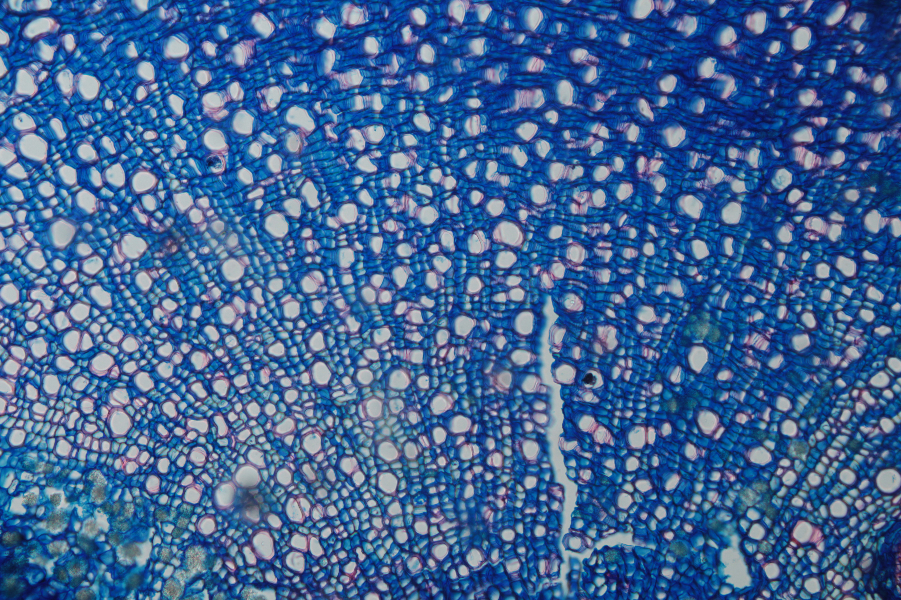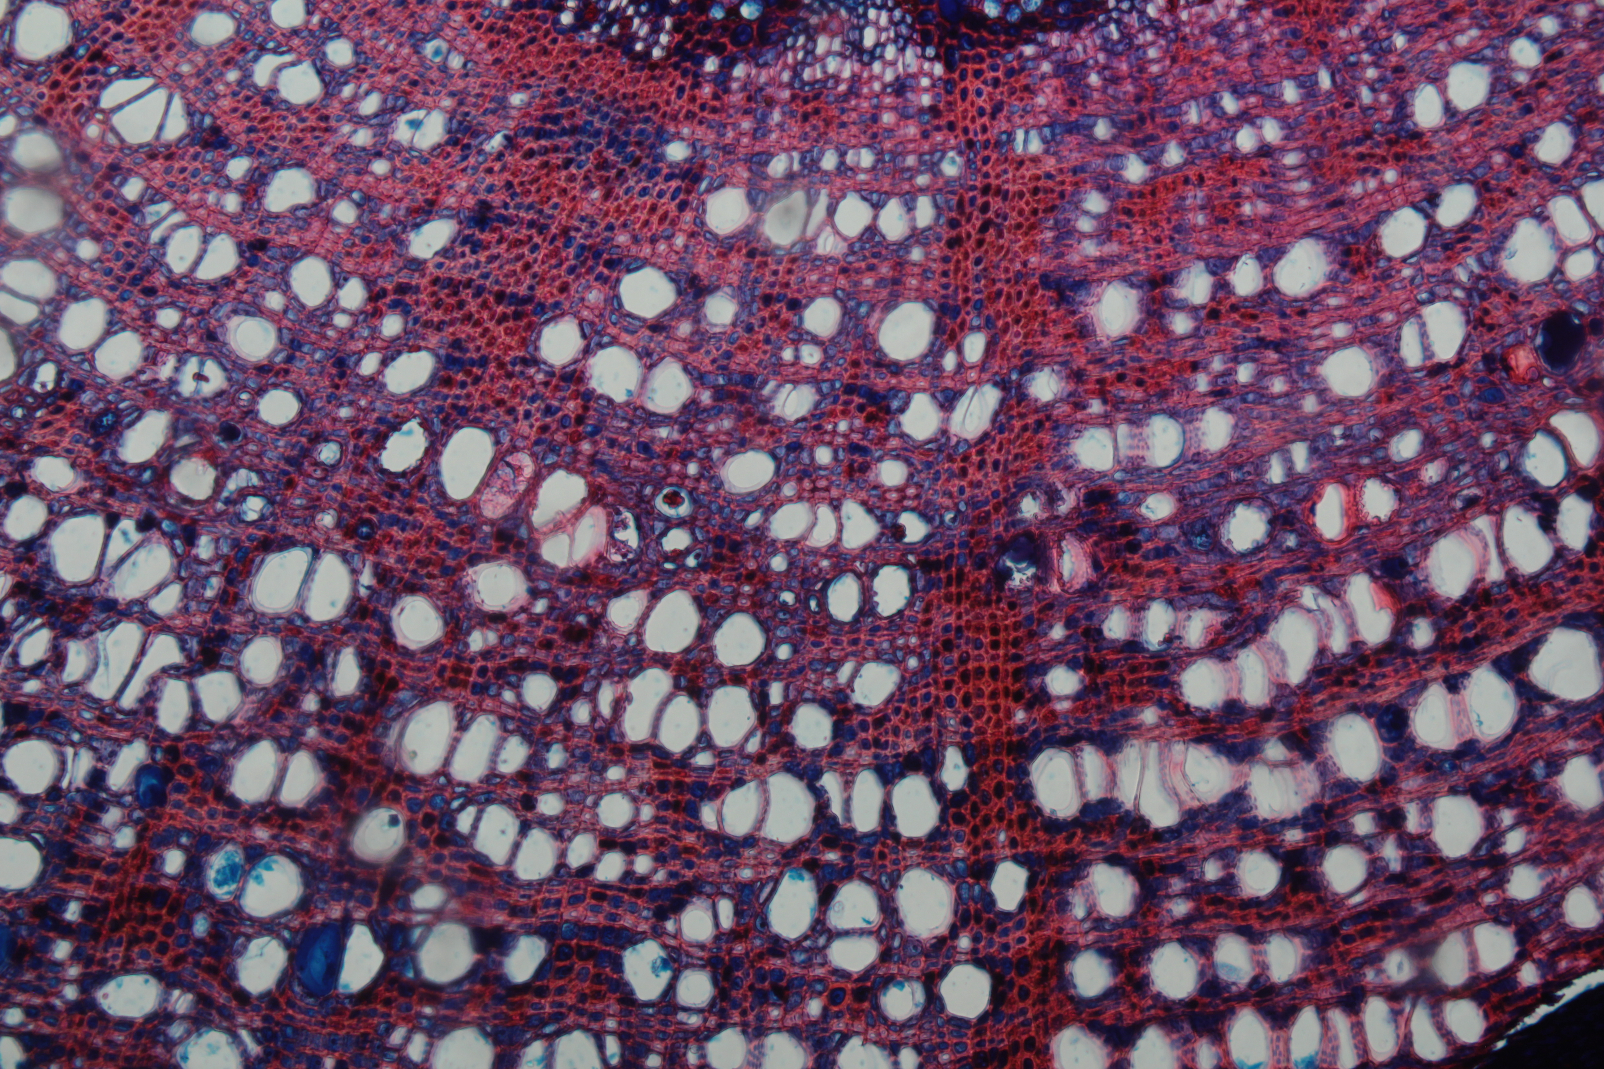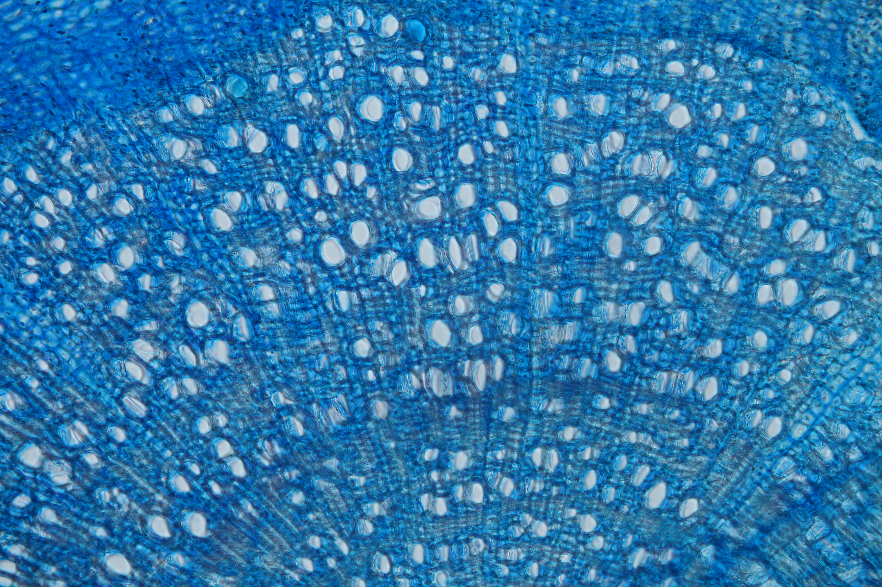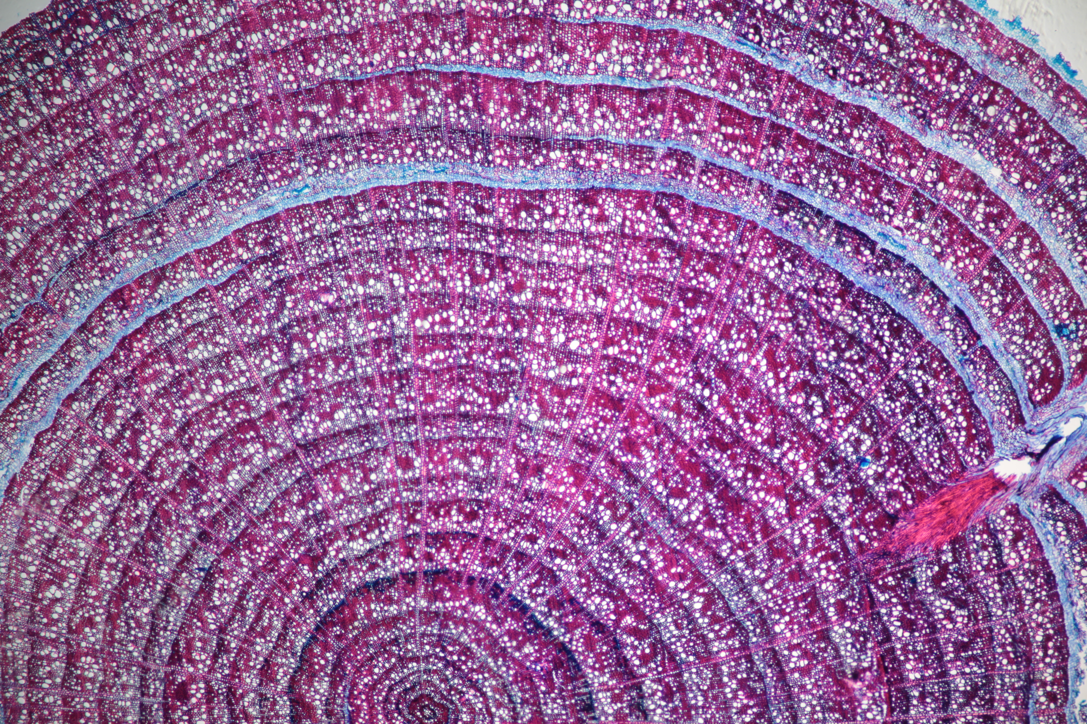

**Fundamental Processes of Terrestrial Life**  
 The stem…

* …needs stability 🡪 lignin production in fibers
* …transports liquids 🡪lignin production in vessels (against tension stress)
* …has to survive 🡪building up storage tissues (rays & axial parenchyma)

**Double-Staining**

* Safranin stains lignified tissues red
* Astra Blue stains non-lignified tissues blue

**Assumption**

* Heavily mechanically stressed plants produce much lignin –   
   non-stressed plants produce few lignin
* Color ratios in xylem represent a plant’s living conditions

**Practical Approach**

«ImageJ» is a public domain image processing program, which was used to digitally analyze photographs of micro sections and automatically generate percentage values of their color ratios. The features «Color Threshold» and «Analyze Particles» provide the necessary functionalities.